**Network Cyber defence project**

PART I

The below image shows the correct configuration of metasploitable and kali linux virtual machines successfully ping each other

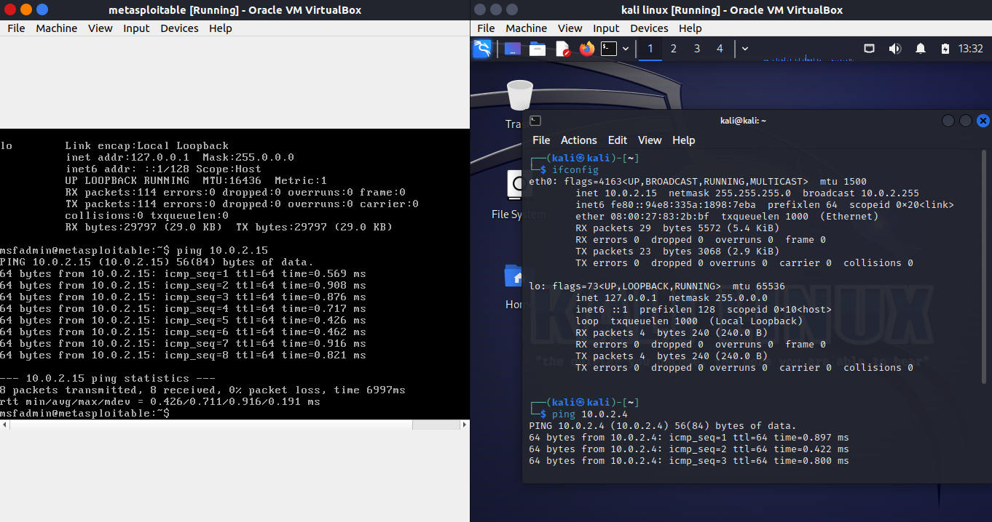

Exploit FTP port 21

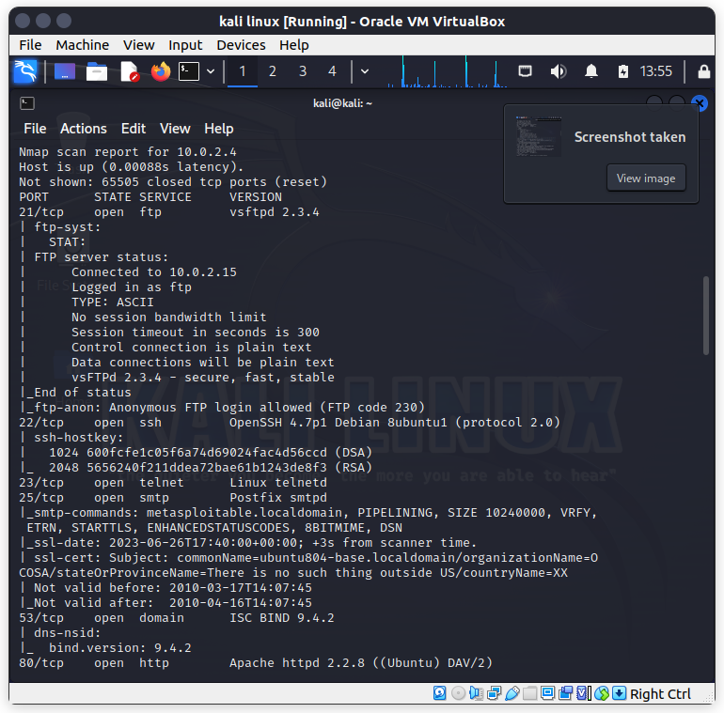

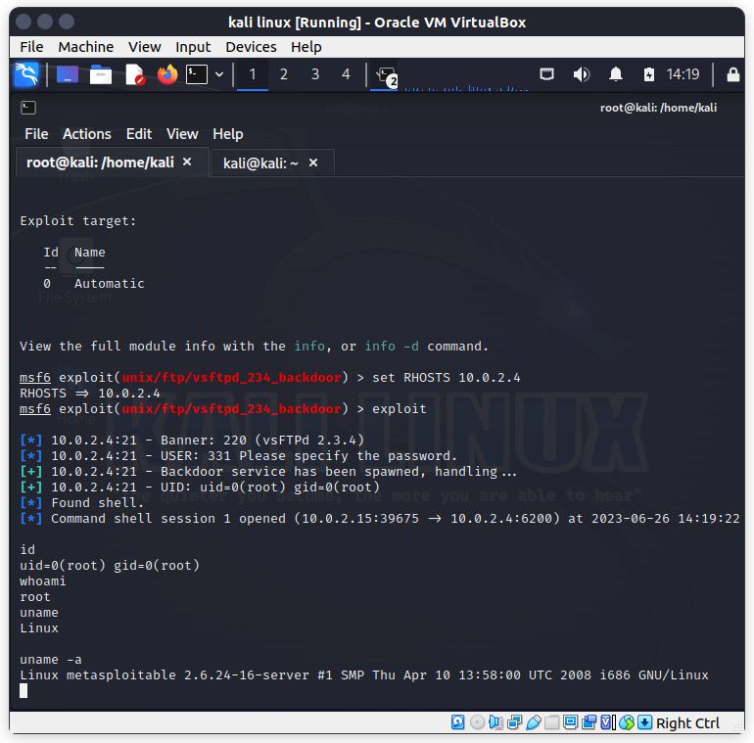

The image above shows the successful exploitation of the FTP port.

Using a bind shell on metasploitable

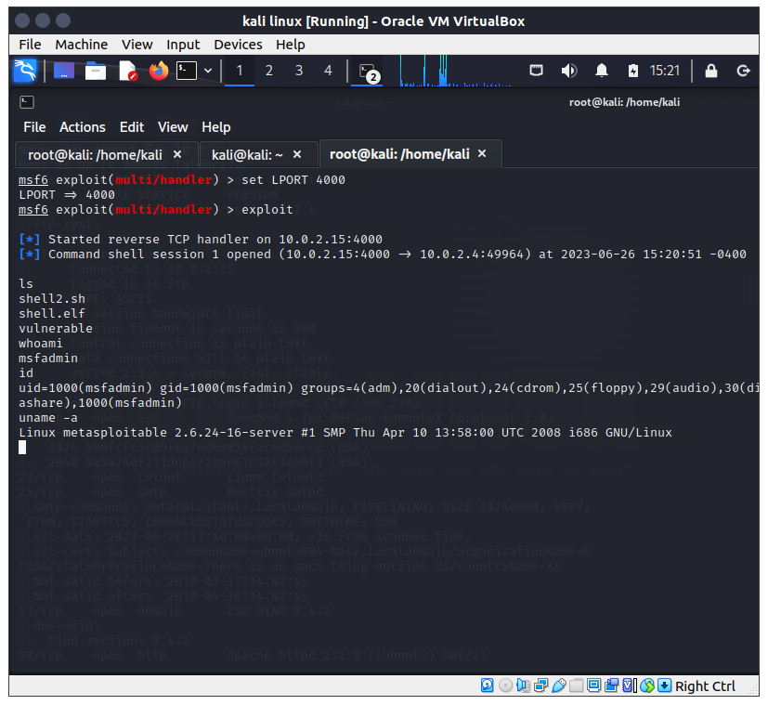

Exploiting discc

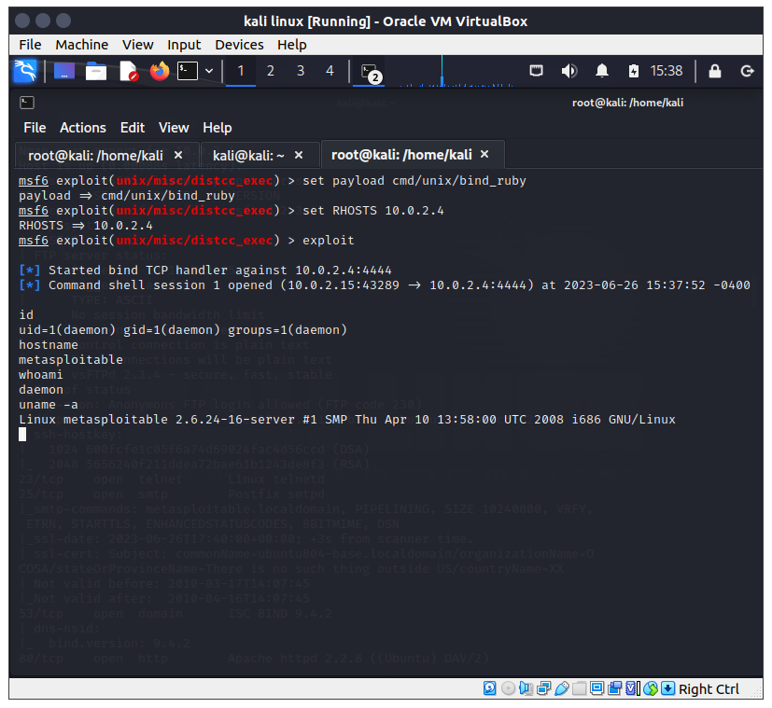

Attacking vnc

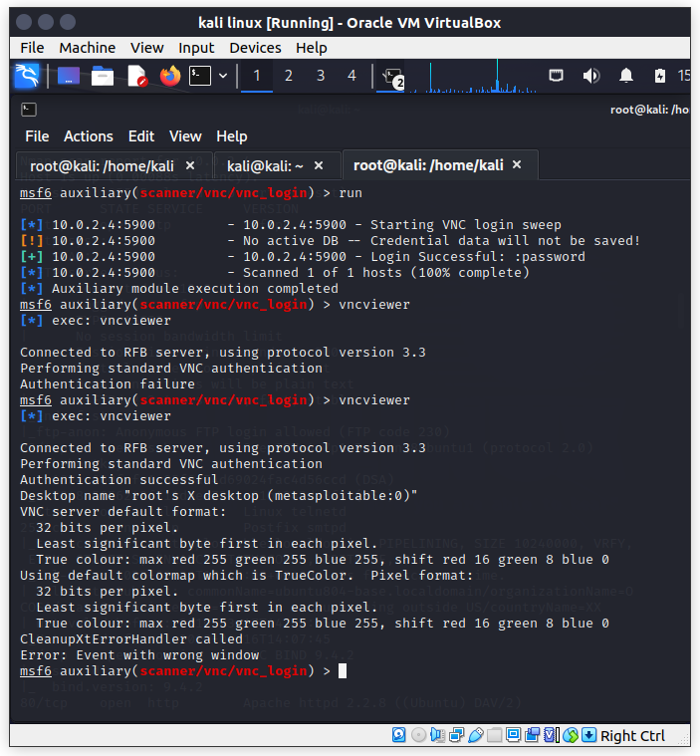

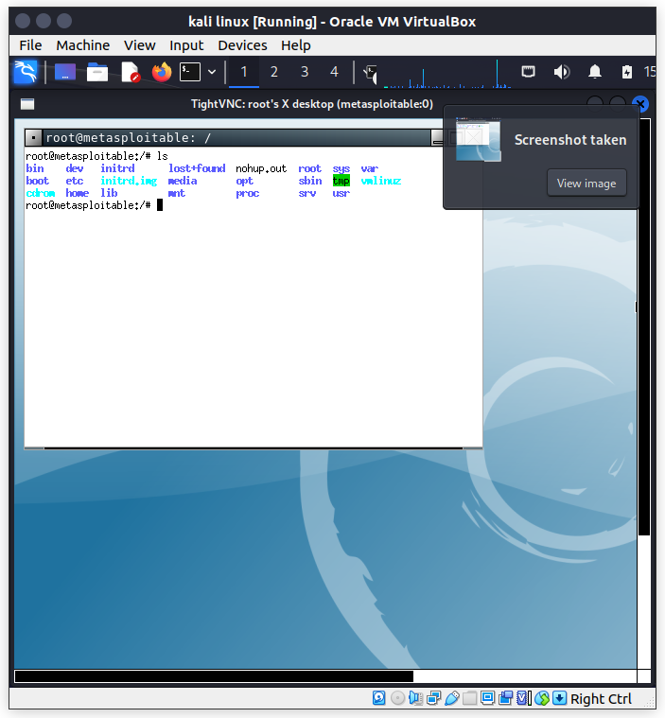

Attacking apache twiki history vulnerability

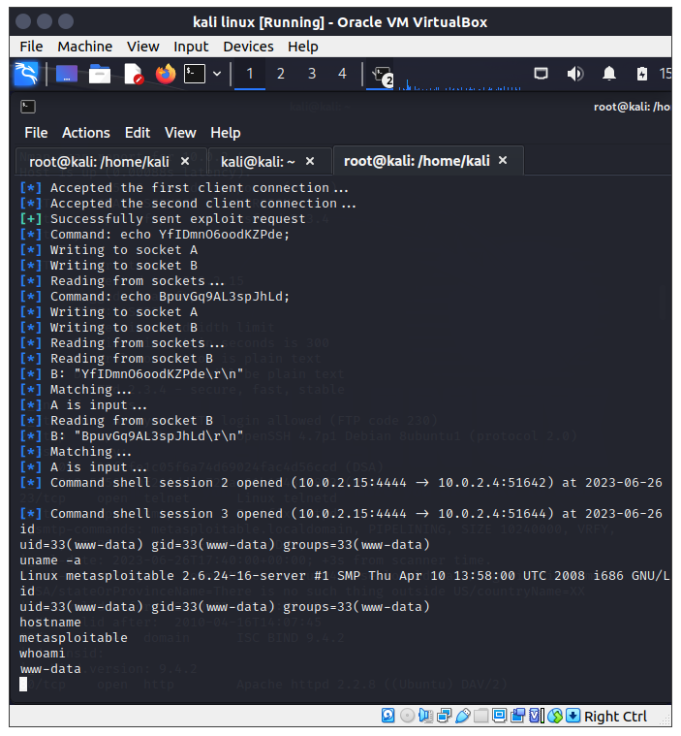

PART II DOS attack.

A challenge to acquire screenshots as the attack kept freezing my machine

